**Node.js Custom Module Assignment**

1. Create a `greetings.js` Module – Write a function `greet(name)` that returns: "Hello, ! Welcome to the Node.js module system." – Export the function as a module.

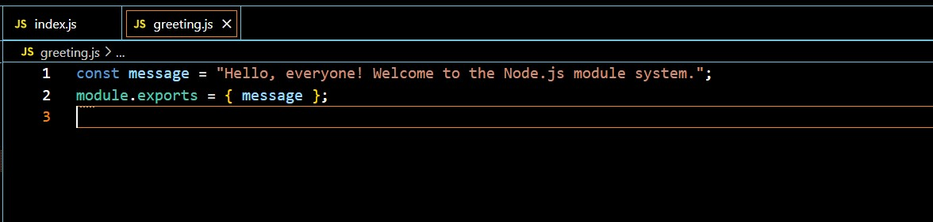

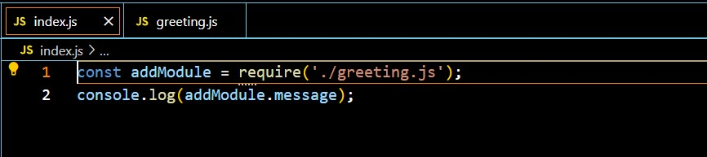

1. Create a `mathOperations.js` Module – Write and export the following functions: - `add(a, b)` - returns the sum of two numbers. –

`subtract(a, b)` - returns the difference between two numbers. – `multiply(a, b)` - returns the product of two numbers. – `divide(a, b)` - returns the quotient of two numbers.

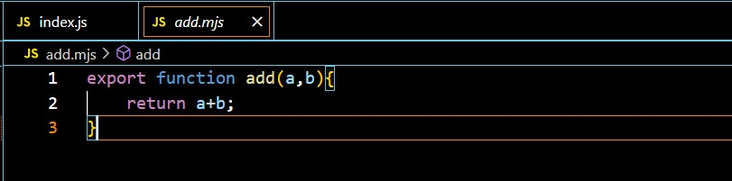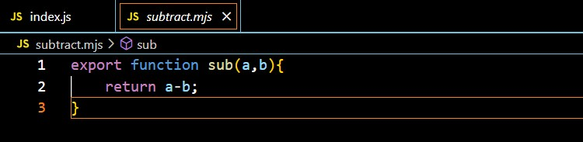

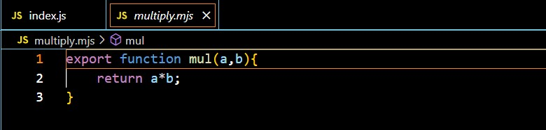

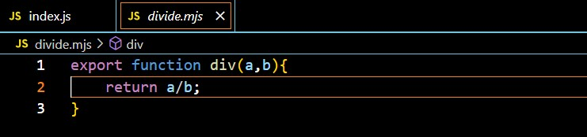

1. Create a `main.js` File –

Import both `greetings.js` and `mathOperations.js`. –

Use `greet(name)` to greet a user. –

Perform all four math operations and log the results

